Data Analysis

Top 100:

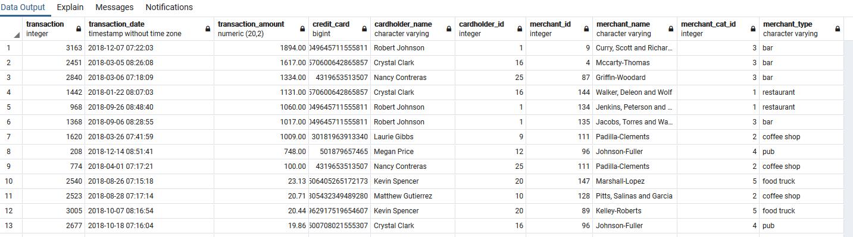

I see some anomalies, specifically with transactions 9-1. These transactions occur at odd hours of the day at considerably high values. 4 transactions on this list occur at bars which are typically closed at this time. 3 of these transactions are on cardholder 1’s card.

Customer 18

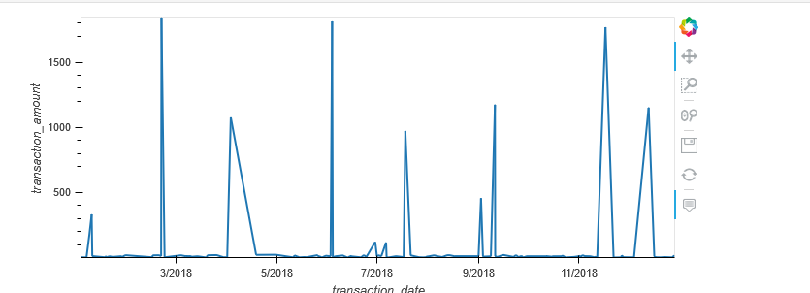

There are 353 transactions that are $2 or less (roughly 10% of total transactions). It is difficult to determine which businesses are most prone for theft; however, the top 5 merchants for transactions under $2 are: Wood Ramirez, Baker inc. Hood-Philips, Martinez Group, and Riggs-Adams.

Customer 2

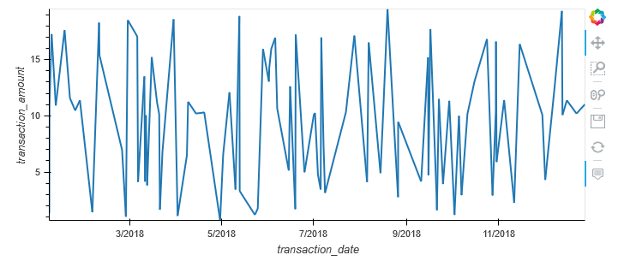

Overlay

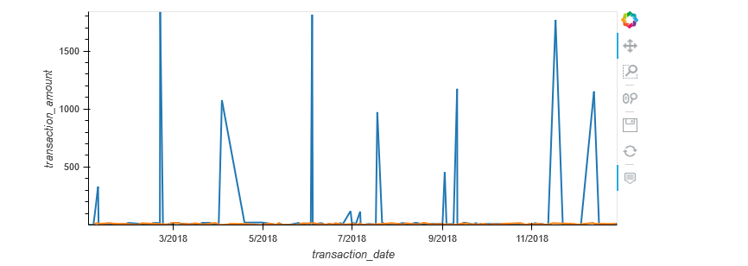

Customer 18 has more outliers regarding transactions. Customer 2 has varying transactions within 0 and 20 dollars. Customer 18 either has large expenses at various times of the year, or has transactions that are easy to identify if the card is stolen.

Customer 25

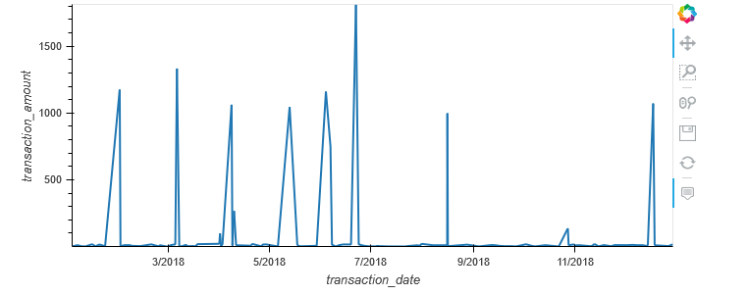

Customer 25 had some uncharacteristic purchases in the first half of 2018. The transaction amounts for these are large enough that the owner should be able to identify what is a valid transaction vs. what is theft.